Project Objectives

- To develop a sustainable high-output grass-based spring milk production system
- To incorporate the most recent advances in grassland management for dairy farms into a high- output system
- Use a type of dairy cow that has good genetic indices for both milk production and fertility
- Employ the best practices from nutrition research and dairy cow husbandry
- Incorporate nutritional studies into a high-output system
- To incorporate management technologies and system attributes that enhance the sustainability of dairy production
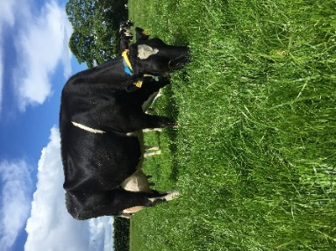
Farm Details Week 24/04/23
Stocking rate on MP (LU/ha) | 3.7
Farm Cover (DM/ha) | 596
Growth Rate (DM/ha/day) | 48
Demand (DM/ha/day) | 44
Average grass DM (%) | 20.8
Average Concentrate fed (kg/day) | 7.6
Average DIM | 62

Cow Details Week 24/04/23
Yield (kg/cow/day) | 33.72
Fat (%) | 4.08
Protein (%) | 3.51
MS (kg/day) | 2.48
SCC | 63,330

Grassland Management:
Silage was cut on the 18th of April from the 3 paddocks (3.16 ha) that were closed last week, and yielded an average of 1530 kg DM/ha. Low covers were taken out for silage to avoid high grazing covers and to maintain grass quality. Cows are being fed on average 7.6 kg/d of a 14% crude protein concentrate in the parlour which is formulated with native ingredients. Cows at 60 - 89 DIM are on 7.5 kg/d (39/57 cows) and cows < 60 DIM on 8 kg/d (18/57). Cows are being offered an average allocation of 12kg DM/d of grass. Average DM of the grass this week was 20.8%.

Comments:
On the 17th of April all 57 cows received a pre-breeding scan to check their reproductive health. Four cows scored 1 on mucosal, but no cows received intervention. The breeding season will commence on 2nd of May for 12 weeks. Breeding is done by AI and will be done twice daily. Heath detection is being done using automatic activity monitoring and scratch cards which will be read in the collecting yard before milking. The bulls selected for this year are:

Bull | Name
FR5857 | OLCASTLETOWN TIERNAN
FR6622 | BAWNGARRA BRÓD
FR8613 | S-S-I URA GRASSFIRE-ET
FR8562 | OCD LEGACY MASSEY-ET
FR7905 | (IG)BUNACLOY ALIBI

The weighted EBI averages of the bulls are:

EBI  € | Milk  SI | Fert  SI | Health  € | Milk  kg | Fat  kg | Prot  kg | F+P  kg | F% | P%
264 | 123 | 105 | 16 | 303 | 24 | 17 | 41 | 0.20 | 0.11

These bulls were selected for high milk fat and protein and milk PTA to ensure the milk fat and protein % stay positive in addition to selecting for balanced milk production and fertility sub-index values.

For more details on the High Output Systems Research Herd visit
https://www.ucd.ie/agfood/about/lyonsresearchfarm/lyonsdairyherd/

